How to install sql server and sql server management studio:
For the sql server:
https://www.microsoft.com/en-us/sql-server/sql-server-downloads From the link choose developer option and in the installation choose basic installation.
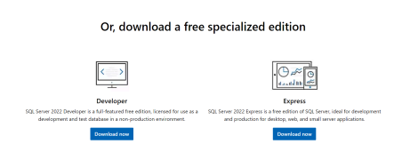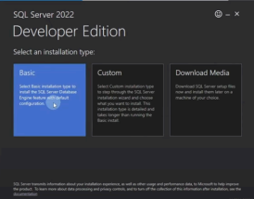
For the sql management studio:
https://learn.microsoft.com/en-us/sql/ssms/download-sql-server-manage ment-studio-ssms?view=sql-server-ver16
Use this link to download sql management studio and then follow the installation .
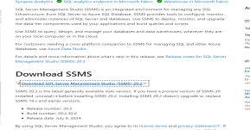
To open the program just open sql management studio, make the encryption : optional instead of mandatory and press connect :
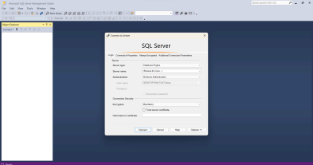If the server name is not there like in this photo , open cmd and write : whoami , the output will be the server name
,copy it and paste it in the program then press connect.